Using DIABOX
Rick Lumpkin

DIABOX is a modification of DOBOX 4.2, a Matlab software package for constructing, inverting and analyzing box inverse models developed at the CSIRO Climate Change Research Program (Morgan, 1994). DIABOX development began in 2000, and has continued under NSF funding (PIs R. Lumpkin and K. Speer, Florida State University). Current development is handled by Rick Lumpkin (Cooperative Institute for Marine and Atmospheric Sciences, Univ. Miami) and Nicolas Wienders (FSU). DIABOX adds explicit air-sea transformation for outcropping layers, includes greater automation than in DOBOX for often-repeated steps, collects global choices for hydrographic sections into a single file, solves for unknowns via Gauss-Markov inversion, and fixes several bugs identified in DOBOX 4.2 code.

Running an inverse model via DIABOX requires several steps:

- identifying the geometry of the box model
- preparing the hydrographic sections for use in DIABOX
- constructing the box model in Matlab
- setting up the matrices and inverting, using DIABOX
- plotting and interpreting the results

In this document, we will describe these steps. As an example, we will present files for an inversion of the North Atlantic using WOCE hydrographic lines (Lumpkin and Speer, 2003).

1. Identifying the box geometry

For a throrough presentation of the box inverse model approach, a reader is referred to Wunsch (1996). In summary, a box model solves for unknowns (reference levels for thermal wind, diapycnal fluxes, adjustments to air-sea fluxes) which satisfy constraints such as property conservation in closed boxes. As the name suggests, a box model consists of one or more boxes, each delineated by coastlines and hydrographic sections.

Why a box model? Summary of strengths, weaknesses. DIABOX focus: minimum interior mixing.

Constructing a box model: what you need.

The geometry of the northern Atlantic four-box model is shown in Fig.1. In this example, an Equatorial Box runs from 11˚S (section A8) to 24˚N (section A5, which exists in two pieces separated by the Bahamas Plateau), with the American continents delineating the western edge and the African continent the eastern edge. A Subtropical Box runs from 24˚N to the nominal 48˚N line AR19, and is separated from the Mediterranean Sea by a section (AR16) running across the Gulf of Cadiz. Although the 48˚N line does not reach the coast of Nova Scotia, it extends to the continental shelf where the water becomes extremely shallow (Fig.1). A Subpolar Box runs from 48˚N to the line AR7E (Ireland to the southern tip of Greenland), and includes the Labrador Sea. Finally, an Overflow Box runs from AR7E to the Denmark Strait (AR18) and the Iceland-Scotland Ridge. As discussed in Chapter 2, an additional “ghost” section, not shown in Fig. 1, is added in order to include flow from the North Pacific to the North Atlantic via the Bering Strait and Canadian Archipelago (Wjiffels et al. reference).

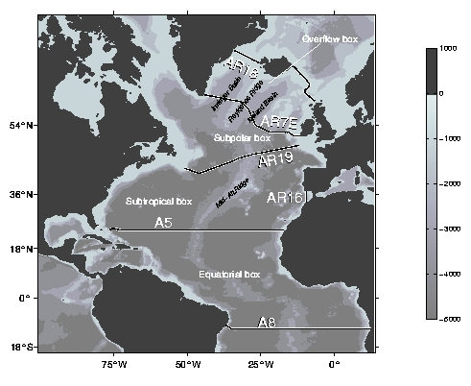
Fig. 1: geometry of the example inverse model. Bathymetry (m) is shaded. In this model, the northern Atlantic is divided into four boxes, defined by seven WOCE hydrographic sections.

2. Preparing section files

2.1 Downloading section files and converting to Matlab format

2.2 Preparing the section files for use in DIABOX

2.3 Adding section-dependent constraints
example: a05fs_con.m

2.4 Adding section-dependent reference levels, a priori reference velocities
uniquerefvels.m

3. Constructing the box model

At this point, you should know what hydrographic sections and continents will define your closed boxes. You have prepared the sections using prepctd.m and step one of DOBOX 2. Now, you’re ready to assemble these pieces into an inverse model.

First, you need to create a subdirectory in your DOBOX directory with a descriptive name. The example we’ll use here is “fourbox”, a four-box model of the northern Atlantic (Fig.1). Within this directory, you will do the following steps:
1. create the geometry file (geo.m)
2. check geometry matrix (checkgeo.m)
3. create polygons outlining the boxes (makeboxcoords.m)
4. add model-specific constraints (addconstraints.m)
5. calculate mean properties (makemprop.m)
6. calculate air-sea fluxes on outcropping layers (makeairsea.m)

3.1. Creating the geometry file geo.m

Within the subdirectory for your new box model, you must first create a file called geo.m. This file must define variables directory, sectfiles, geometry, properties, masssecterror, masstotalerror, and consSILCAT. Optionally, you may define variables reflevel, rv and vmag. These optional variables may also be defined in the global file uniquerefvels.m, and if they are defined there, the entries in geo.m will be ignored. For “fourbox”, the geo.m file is:

directory='/phod007/lumpkin/dobox/sections/';

sectfiles=[ directory,'a08.mat '; ...
directory,'a05fs.mat '; ...
directory,'a05int.mat '; ...
directory,'ar16d.mat '; ...
directory,'ar19a.mat '; ...
directory,'arch.mat '; ...
directory,'ar07ed_ebc.mat'; ...
directory,'ar18e1.mat '; ...
directory,'ice2scot.mat '];

geometry=[[1 -1 -1 0 0 0 0 0 0]; ...
[0 1 1 1 -1 0 0 0 0]; ...
[0 0 0 0 1 -1 -1 0 0]; ...
[0 0 0 0 0 0 +1 +1 1]];

reflevel=[26 -1 13 10 15 -1 15 12 12]; % reference levels
rv= [ 0 .31 0 0 0 0 0 0 0]; % reference velocities
vmag=.01*[ 1 5 1 10 2 5 5 10 10]; % magnitude, x(indv)

properties=['mass '; 'salam'; 'potmp'];

masssecterror=1e6*[2 2 1 .25 1 .01 .5 .25 .25];

% net volume imbalance per box, assuming non-synoptic
% error from section to section are independent.
masstotalerror=sqrt(sum((abs(geometry).* ...
(ones(size(geometry,1),1)*masssecterror.^2))'));

% consSILCAT(nboxes): set to 1 to conserve net silicate
consSILCAT=[0 0 0 0];

directory is the directory where the prepared section files (or soft links to them) can be found. See Chapter 2 for a discussion on how these files are created.

sectfiles contains the name of the prepared section files used in your box model. Note that each entry must have the same number of characters, so extra spaces (which are ignored) are added to the end of many entries. After executing “geo” in Matlab, you can see how many section files you are using by “size(sectfiles,1)”.

geometry is a matrix of ones, zeros and negative ones. This matrix tells DOBOX how the boxes are bound by the sections. For more information, see section 3.1.1, “constructing the geometry matrix”.

reflevel gives the thermal wind reference levels (model level numbers) for each section. This is ignored if it is also specified in uniquerefvels.m.

rv gives the a priori reference velocities. This is ignored if also specified in uniquerefvels.m.

vmag gives the rms magnitude of adjustments to the a priori reference velocities. This is ignored if also specified in uniquerefvels.m.

properties lists the conserved properties.

masssecterror is the …

masstotalerror is the …

consSILCAT tells the model …

3.1.1 Constructing the geometry matrix

Each row represents a box: the number of boxes in your model is “size(geometry,1) ”. Each column represents a section file: the number of columns is the number of section files, so you must satisfy “size(sectfiles,1)==size(geometry,2)”.

Each row of geometry (each box of the model) consists of a string of ones, zeros and negative ones. Row one defines how each of the sections bounds box one (the Equatorial Box in our example). The first entry of this row corresponds to section file one, “sectfiles(1,:)”. If box one is not bounded by section one, this entry will be zero. If it is bounded, the value is +1 or –1. The sign convention is identical to DOBOX 4.2 (Morgan, 1994, pg. 21): mentally draw an arrow from the first cast in the section file to the final cast. If this arrow is part of a counter-clockwise path around the box, the entry will be +1. If it is part of a clockwise path around the box, the entry will be –1. We illustrate with a simple example:

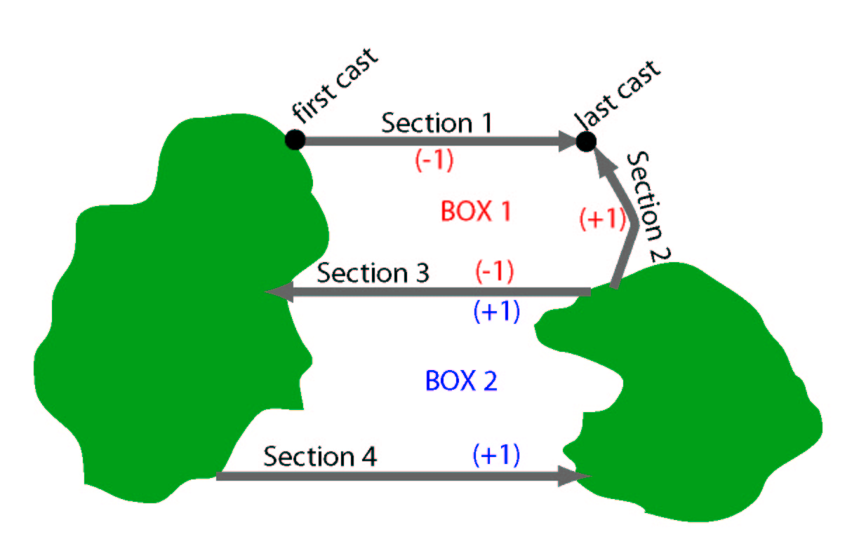
Fig.C: example geometry: two boxes bounded by two land masses and four sections.

In Fig.C, Box 1 is bound by sections 1, 2 and 3. Because Section 1 runs west-to-east, it is shown as an arrow pointing eastward. A counter-clockwise circuit around Box 1 runs in the opposite direction, so the appropriate entry in geometry for Section 1, Box 1 is –1 (geometry values shown in parentheses). For this example,
geometry=[ [-1 +1 –1 0];
[ 0 0 +1 +1] ];

SHORTCUT: for very large geometries, such as a global inversion with dozens of sections and boxes, most of the matrix geometry will be zeros. This is because a section usually defines the edges of at most two boxes (an entry of 1 or –1), and all other row entries for this section’s column will be zero. In the case of a model with dozens of boxes, hard coding the matrix is undesirable: rows will wrap across lines, negative signs will confuse spacing, and it becomes almost impossible to avoid typographical errors. Furthermore, you may wish to add or remove a single section – a nightmare with a large, hard-coded geometry matrix! Instead, create the matrix as in this example:

% first, initialize “geometry” as a vector of zeros
geometry=zeros(1,size(sectfiles,1));
% Equatorial Box
bn=1; % box number
geometry(bn,sectname2sectnum('a05int',sectfiles))=-1;
geometry(bn,sectname2sectnum('a05fs',sectfiles))=-1;
geometry(bn,sectname2sectnum('a08',sectfiles))=1;
% Subtropical Box
bn=bn+1;
geometry(bn,sectname2sectnum('ar19a',sectfiles))=-1;
geometry(bn,sectname2sectnum('ar16d',sectfiles))=1;
geometry(bn,sectname2sectnum('a05int',sectfiles))=1;
geometry(bn,sectname2sectnum('a05fs',sectfiles))=1;
% Subpolar Box
bn=bn+1;
geometry(bn,sectname2sectnum('ar07ed_ebc',sectfiles))=-1;
geometry(bn,sectname2sectnum('ar19a',sectfiles))=1;
geometry(bn,sectname2sectnum('arch',sectfiles))=-1;
% Overflow Box
bn=bn+1;
geometry(bn,sectname2sectnum('ar18e1',sectfiles))=1;
geometry(bn,sectname2sectnum('ice2scot',sectfiles))=1;
geometry(bn,sectname2sectnum('ar07ed_ebc',sectfiles))=1;

This code would be inserted in geo.m in place of a hard-coded matrix definition for geometry. The code isn’t smart enough to know whether an entry should be 1 or –1, but it’s far preferable to a hard-coded matrix when your model has a dozen boxes! The routine sectname2sectnum.m scans through sectfiles, identifies the row number which contains the section name (the first argument passed to sectname2sectnum.m), and returns this row number. The code above then assigns this to the appropriate column number of geometry, thus avoiding a potential typographical error.

If step 3.1 has been completed successfully, you should be able to “cd” to your model file from within Matlab and enter “geo”. The variables directory, sectfiles, geometry, etc. should now be defined in your workspace.

3.2 check geometry matrix

Did you construct the matrix geometry correctly? It’s easy to make typographical errors, like putting a +1 where you meant –1 or getting that 1 in the wrong column. First, notice that “interior” sections, those which separate one box from another, and thus bound two boxes, have a –1 for one box and a +1 for the other. “Exterior” sections, which define the edge of only one box (like A8 in our example), have only one –1 or +1. Therefore, if you type “abs(sum(geometry,1)) ”, the +1s and –1s should add to zero for interior sections. Thus, “sectfiles(find(abs(sum(geometry,1))),:) ” should list ONLY THE EXTERIOR SECTION FILES. Verify this. For our example, these are a08.mat, ar16d.mat, arch.mat, ar18e1.mat, and ice2scot.mat. If the command given above also listed ar19a.mat, we would know that there’s a typographical error in geometry: ar19a should have the entry –1 for the Subtropical Box and +1 for the Subpolar Box, which would add to 0 and thus not be included in the find.

A more comprehensive check of geometry can be made visually using the script checkgeo.m. Type this:
clear all; checkgeo;
The routine checkgeo.m uses the variables in geo.m to draw a map of your box model’s geometry. For the fourbox example, the figure looks like this:
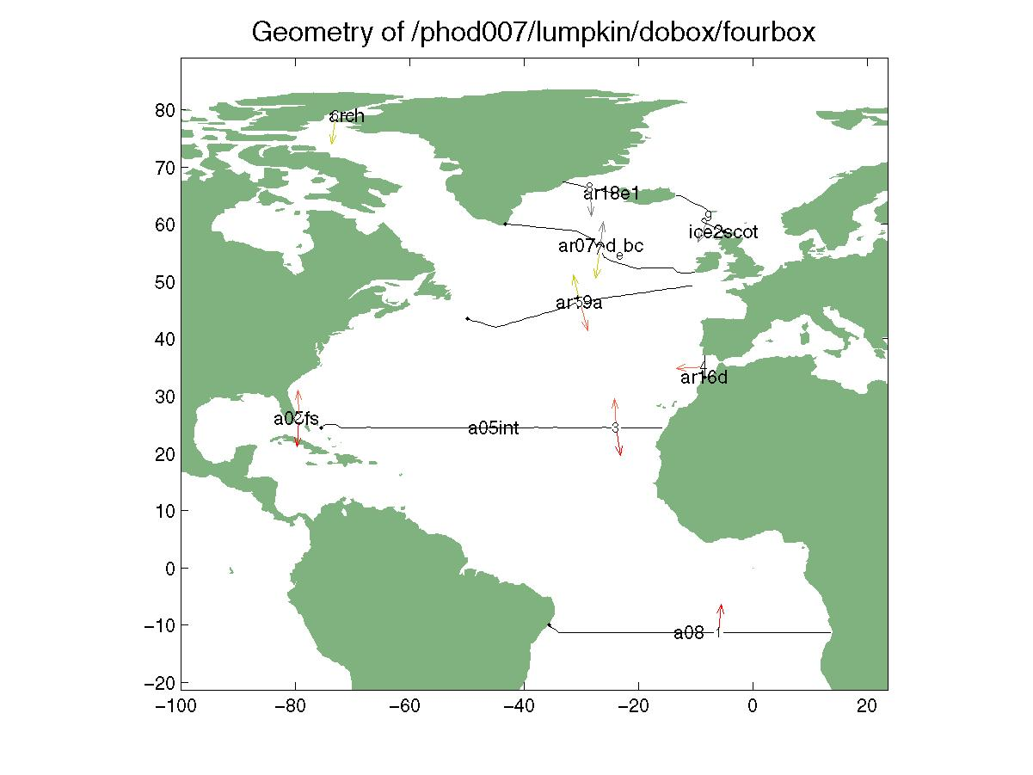
Fig.B: example output of checkgeo.m

Each section’s casts are plotted as a black line, with a small black bullet plotted at the first cast. Superimposed on each section’s cast line is the name of the section file and its section number (column number in sectfiles). Colored arrows point from each section into the boxes they bound. Each box is color-coded, with a color chosen at random. If checkgeo.m happens to choose indistinguishable colors for adjacent boxes, rerun it.

In the example Fig.B, bounding sections for the Equatorial Box (box 1) are indicated by red arrows. These sections all have entries of +1 or –1 in “geometry(1,:)”. If a section is showing a red arrow, but does not bound box 1, there’s been a typo in geometry. For example, if Fig.2 had a red arrow on ar19a (section 5), then “geometry(1,5)” is –1 or +1, but should be 0.

The direction of the arrow tells you if you’ve entered the correct sign for that section’s entry in geometry. It should POINT INTO THE BOX, as in Fig.B. If the red arrow (box 1) for a08 (section 1) were pointing southward, away from box 1, then you would know you had made a sign error in “geometry(1,1)”.

Similarly, in Fig.B the four sections bounding box 2 each have an orange arrow which points into the Subtropical Box. The three sections bounding box 3 have yellow arrows pointing inward. The three sections bounding box 4 have gray arrows pointing inward. There are no misplaced red, orange, yellow or gray arrows, all point inward … all is well!
3.3 create polygons defining the boxes, using makeboxcoords.m

When DIABOX adds air-sea fluxes to a box in your inverse model, it will need to know if a gridded value from the COADS or NCEP fields is inside the box. To allow for this, you must create box coordinate files, one for each box, using makeboxcoords.m.

Enter “makeboxcoords”. The map of your box model appears, similar to the output of checkgeo.m. In addition, blue stars appear wherever rivers flow into the oceans. Matlab prompts you to “Zoom to the desired box (“enter” when done)”. Using the mouse, click and drag so that box 1 fills the screen. You may wish to click the corner of the figure and enlarge it. Once box 1, and all the rivers that flow into it, are easily seen on the screen, move the mouse to the Matlab window and hit “enter”. Matlab now prompts you to “Mouse-click to define box (“enter” when done)”. You must now click points which define a closed polygon, enclosing all the oceanic area within box 1, excluding the oceanic area not in the box, and including the rivers flowing into the box. It will also contain parts of the land masses which are not in your oceanic box … this doesn’t matter and is ignored. In the fourbox example, the polygon runs along the path of A8, up the Andes along South and Central America, around the Gulf Coast of North America (and thus includes the Caribbean Sea and Gulf of Mexico in the box), down the Florida Peninsula to A5, along A5 to Africa, and down Africa to the eastern end of A8. You can start anywhere on this path, and go clockwise or counter-clockwise. As you click, you are defining the (latitude, longitude) points of a polygon. Once you’re done, hit “enter” and the polygon is superimposed on the figure. Matlab prompts for “Box number?” Enter “1” for box 1, and a new file appears in your subdirectory: boxcoords1.mat. This file contains the variables lat, lon which are also currently in your workspace.

The polygon doesn’t have to be perfect, but it should do a reasonable job of following the hydrographic sections where they delineate your box and should not enclose a significant amount of oceanic area which is not in your box. In this context, “significant” means none of the 1˚-square grids of COADS should reside within the polygon if the bin is not at least partially within the box, and none of the grids residing within the box should be excluded from the polygon.

To verify that the boxcoords polygon is successfully identifying water in your box, type “checkboxcoords(1)”. A map of the world is plotted, and superimposed is a five-by-five degree grid of points which lie within box 1 (the box number is the argument of checkboxcoords.m). If this looks good, continue with the rest of your boxes.

NOTE: boxes which wrap around the dateline. How to.

Once you have created all the box coordinate files, run “checkgeo(‘geo’)” (note the added argument). Now, in addition to the previous output of checkgeo.m, the script adds color-coded box numbers at the center of each box’s polygons.

3.4 create addconstraints.m

Some constraints are specific to a hydrographic section – you want to apply them every time you use a particular section. As described in section 2.3, these should be placed in master files. You may also wish to add geometry-dependent constraints to your model. For example, if section A8 (11˚S) is the southernmost section in your model geometry, you might wish to constrain the net mass transport across A8 to account for the lack of information further south. In another geometry, which extends further south, you may wish to relax this constraint and let explicit property conservation determine the net transport across A8.

You can add geometry-dependent constraints to your inversion in a file called addconstraints.m, which should be created in the model geometry subdirectory. This file will contain repeated blocks of text, each adding a single constraint to the solution, which look like this:

sectnum=sectname2sectnum('arch');
statnum=[];
propnum=1;
boxnum=3;
layernum=nlayers+1;
fluxvalue=0.8e6;
fluxerror=masssecterror(sectnum)^2;
addcon;

sectnum: the section number. You can use sectname2sectnum.m to get this. If the constraint is to be applied to more than one section (example: 0 Sv across two sections), sectnum can be a vector of section numbers.
statnum: the cast (station) numbers. For example, you may wish to impose a western boundary current transport to stations 1—25 of a section running west-to-east. Enter the station numbers as they appear in the prepared Matlab files. If “statum=[] ” has been entered, the constraint will be applied to all casts in the section(s). NOTE: the code assumes that there is only one section in sectnum if station numbers are specified in statnum. I have no idea what would happen if you specify station numbers and multiple section numbers.
propnum: the property number, specified in the section files. By DOBOX convention, 1=mass, 2=salt and 3=heat.
boxnum: the box number. Only one value can be given. It can be
layernum: the layer number(s). Set to “nlayers+1” to apply the constraint to all the layers, i.e. make the constraint a top-to-bottom constraint.
fluxvalue: the value you wish to constraint the transport. As currently constructed, DIABOX assumes the units are SI. Volume transports are m/s, so 5Sv should be entered as “5e6”.

3.5 calculate mean properties, using makemprop.m

sdf

3.6 calculate air-sea fluxes on outcropping layers, using makeairsea.m

sdf

Congradulations! You’ve set up your box inverse model and are now ready to set up the matrices and vectors and solve for the unknowns in a few keystrokes …

4. Setting up the matrices and inverting

5. Plotting and interpreting results

References

Lumpkin, R. and K. Speer, 2003: Large-scale vertical and horizontal circulation in the North Atlantic Ocean. J. Phys. Ocean. 33 (9), 1902-1920.
Morgan, P. P., 1994: Box Inverse Modelling with DOBOX 4.2. CSIRO Marine Laboratories Report 225, 26pp.

